ECO602

9/14/2021

Amanda Klehr, Amira Spikes, John Slaff

In-Class Assignment 2

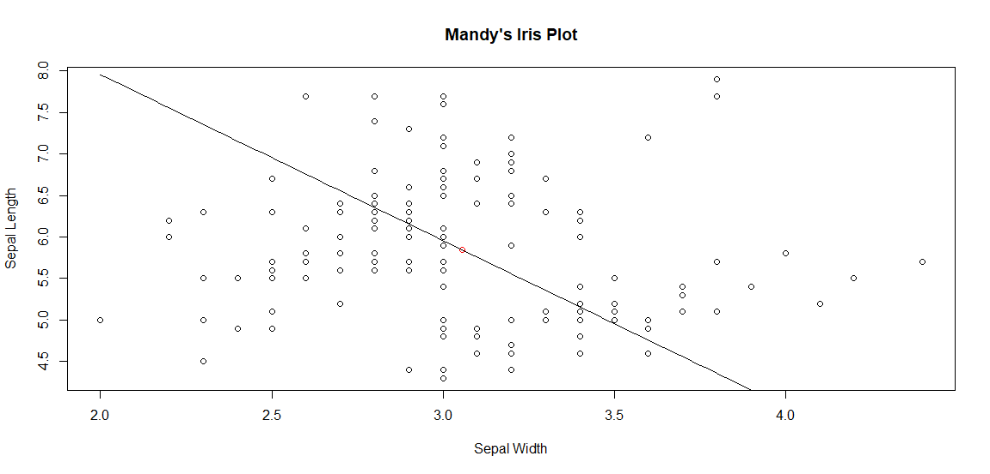

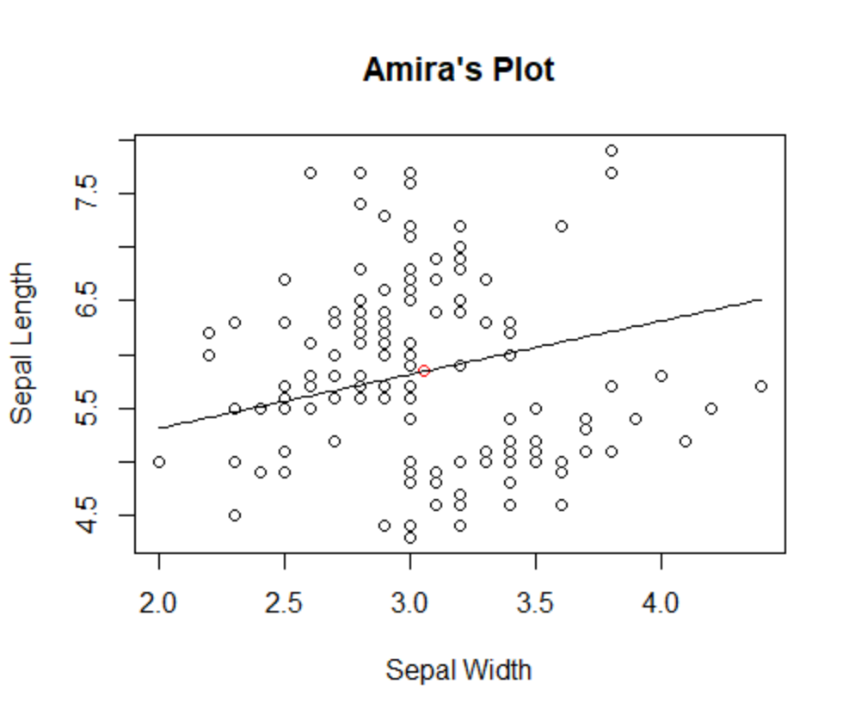

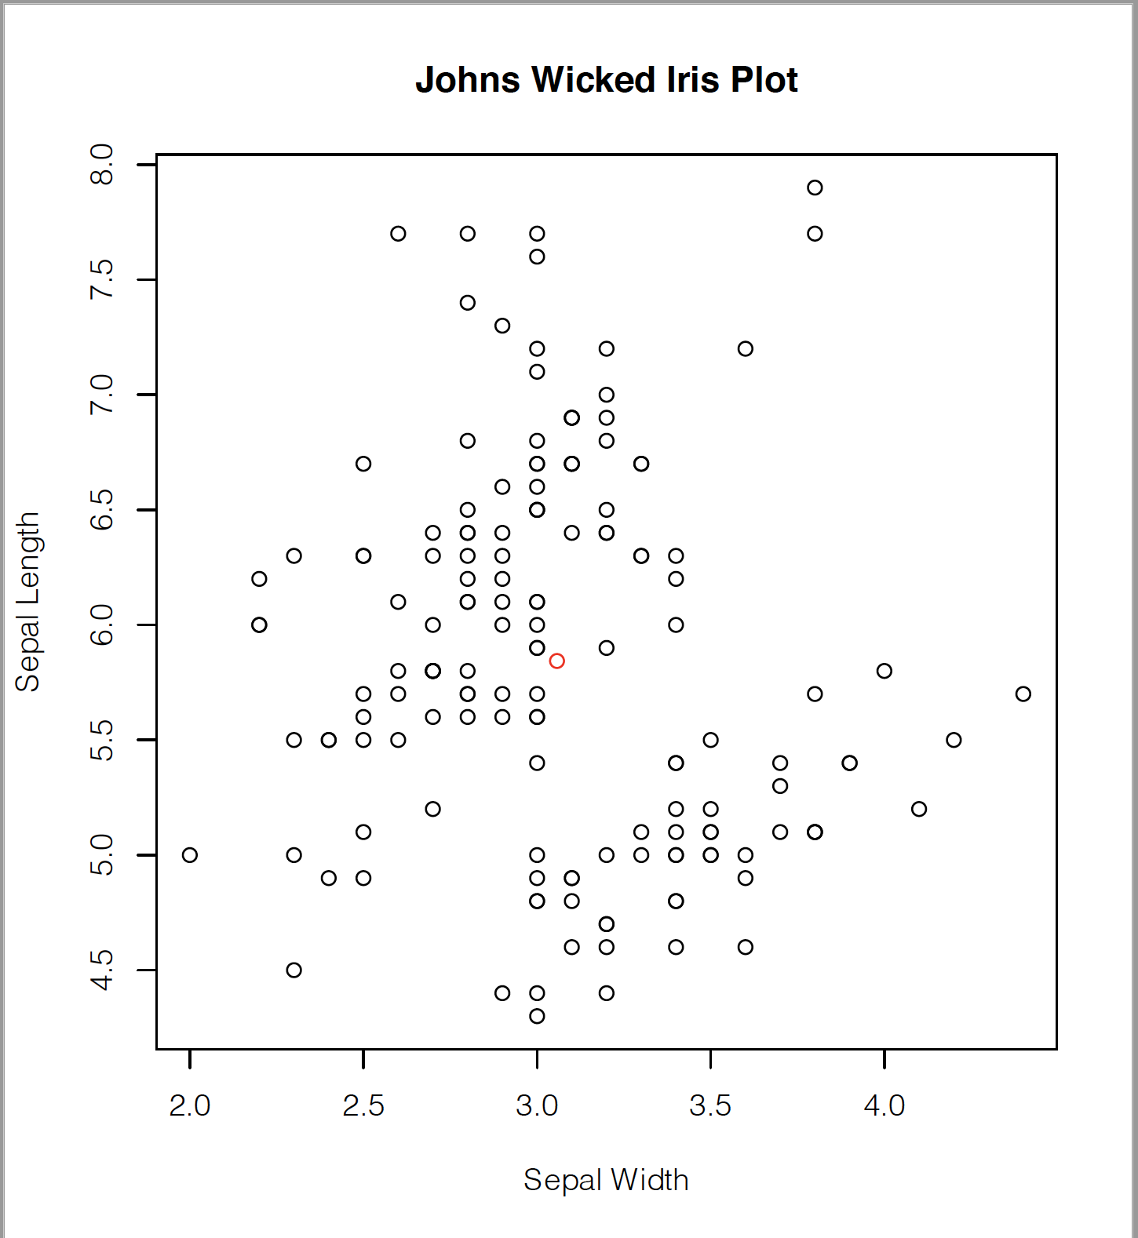

John was unable to create the line with the time allotted, ~½ hour spent after class attempting to make it work but I wasn’t able to.